1. Ask for the name of the user
2. Modify your previous code using the following functions:
   1. date("H") - function that gets server HOUR
   2. date("D") - function that gets server DAY
3. if the hour of the day is 6AM to 12NN then Display “Good Morning”

if the hour of the day is 12:01 PM to 6PM then Display “Good Afternoon”

else, Display “Good Evening”

1. Display the Name of Day
2. In addition to displaying the name of day… give a little description of the day, for example:

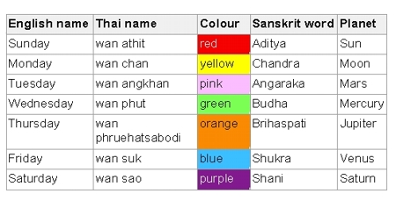

SAMPLE OUTPUT:

Good Afternoon CATHIE, today is Saturday taken form the planet Saturn and the color of the day is purple ☺

Good Morning CATHIE, today is Monday, in Thai, Monday is wan athit and in sanskit it is Aditya

Good Afternoon CATHIE, today is Wednesday, you’re halfway to your weekend so kapit lang.